MatchmakerAI – Comparative Report: Before vs After Resampling

1. Introduction
MatchmakerAI is a machine learning project that predicts whether a person is single or not single based on a combination of textual input (essay) and age. The project focuses on building a reliable and fair classification system while correctly handling class imbalance.
This report compares two experiments: - Model trained before resampling (imbalanced data) - Model trained after resampling (balanced training data)
The objective is to analyze how resampling affects accuracy and overall reliability.

2. Dataset Overview

Input Features
- Essay: Free-text self description
- Age: Numeric feature

Target Variable
- Relationship status: single / not_single
The feature height was excluded because it did not contribute meaningful predictive power and added unnecessary noise.

3. Experimental Setup
To ensure a fair comparison, both experiments used: - The same dataset - The same train–test split - The same preprocessing pipeline - The same machine learning model (Logistic Regression)
The test set was never modified in either experiment.

4. Experiment 1: Training Before Resampling

4.1 Description
In this experiment, the model was trained on the original imbalanced training data.
The majority class (single) heavily dominated the dataset, while other classes were underrepresented.

4.2 Results (Before Resampling)
Overall Accuracy: ~93%
Observations: - Accuracy appears very high - The model predicts the majority class most of the time - Minority classes show extremely low recall and F1-scores
This high accuracy is misleading because it does not reflect true learning across all classes.

4.3 Confusion Matrix – Before Resampling
📌 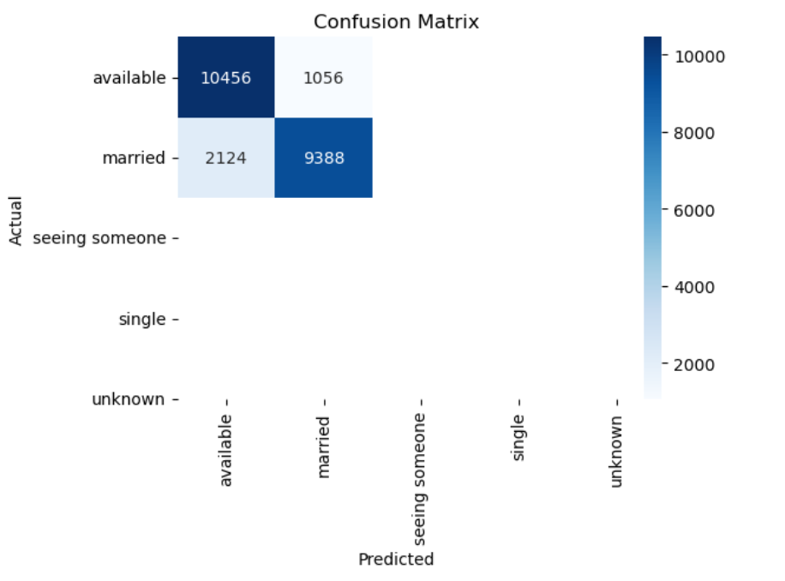

4.4 Classification Report – Before Resampling
📌 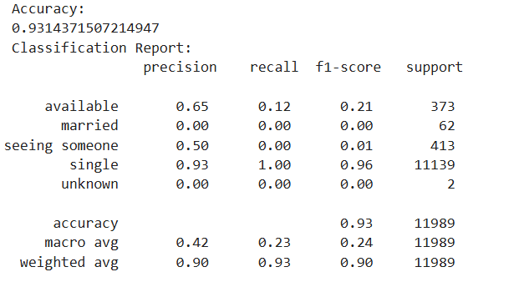

4.5 Interpretation
Although the accuracy is high, the model performs poorly on minority classes. This indicates a biased model that learned to favor the dominant class rather than understanding meaningful patterns.

5. Experiment 2: Training After Resampling

5.1 Description
In this experiment, upsampling was applied only to the training set to balance the classes.
Resampling details: - Random sampling with replacement - Classes made equal in size - Fixed random seed for reproducibility
The test set remained unchanged.

5.2 Results (After Resampling)
Overall Accuracy: ~86%
Observations: - Accuracy decreased compared to the first experiment - Precision and recall became more balanced - The model learned to distinguish between single and not_single more fairly
The drop in accuracy reflects a more honest and realistic evaluation.

5.3 Confusion Matrix – After Resampling
📌 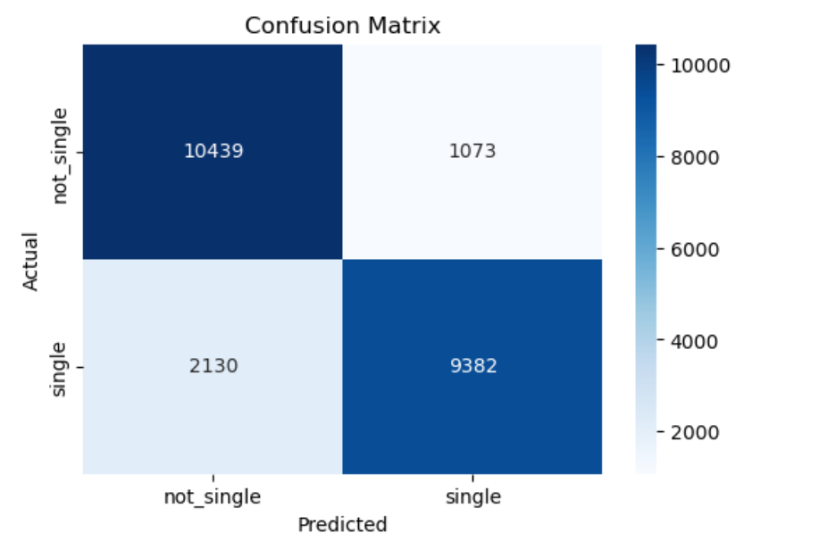

5.4 Classification Report – After Resampling
📌 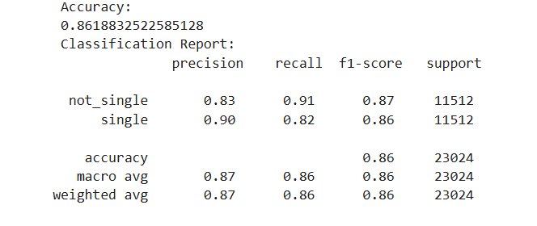

5.5 Interpretation
After resampling, the model no longer relies on class dominance. Instead, it learns patterns from both classes, resulting in improved recall and F1-scores for the minority class.

6. Accuracy Comparison Summary
Metric | Before Resampling | After Resampling
Accuracy | High (~93%) | Lower (~86%)
Reliability | Misleading | Trustworthy
Class Bias | High | Reduced
Minority Recall | Very Low | Significantly Improved

7. Why Accuracy Decreased After Resampling
The decrease in accuracy is expected and desirable: - The model can no longer exploit class imbalance - Predictions are distributed more fairly - Performance reflects real-world behavior
Accuracy alone is not sufficient when dealing with imbalanced datasets.

8. Conclusion
This comparison demonstrates that: - High accuracy on imbalanced data can be misleading - Resampling the training data improves fairness and robustness - A lower but balanced accuracy represents better real-world performance
The final deployed MatchmakerAI model uses resampled training data and is evaluated on an untouched test set, ensuring honest and defensible results.

9. Final Takeaway
A reliable model is not the one with the highest accuracy, but the one that performs fairly across all classes.

